**Col. Beth Makros, No. 5, Spirit Number 399**

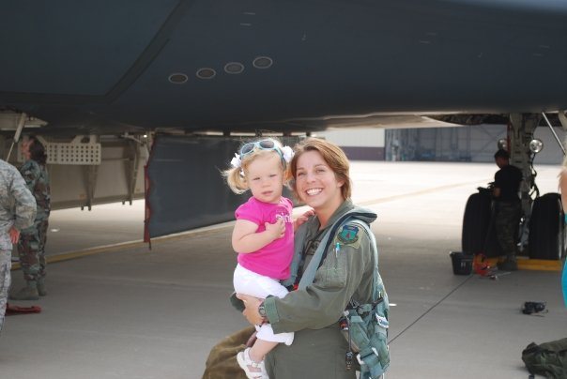

**By Brye Steeves**

**509th Bomb Wing Public Affairs**

Beth Makros regularly – and quite intentionally – brings her three daughters into her office on base. She’s done this at other bases she’s been stationed at since her first baby was born, just months before Makros started to train as a B-2 pilot at Whiteman AFB.

Makros likes to take her girls to the flightline, to promotion and graduation ceremonies, and even just down the hallways where official portraits of the base’s commanders hang. Her picture has been displayed on many of those walls.

The subtle, unspoken message to her daughters: “This is a normal thing for moms. You can do this, too.”

She, too, grew up with this kind of encouragement. Her dad, who was a navigator on C-141s and F-4s and later a test pilot for multiple aircraft, took her to work with him, Makros says, remembering, “I was out on the ramp a lot.”

By 8 years old, Makros knew she wanted to be a pilot, though she often heard that’s not something a girl can do.

Makros earned her wings in 2001. In 2007, she had become the fifth woman to pilot the B-2.

“Every day you feel different,” Makros says. “Every moment of every day, you notice it. It gets more evident as you get older and move up.”

First she tried to ignore it. Then she tried to fit in. Now she embraces it. It can be lonely, but it is also gratifying being part of such a small group.

What would Makros tell her three daughters?

“There should be a lot more of us.”